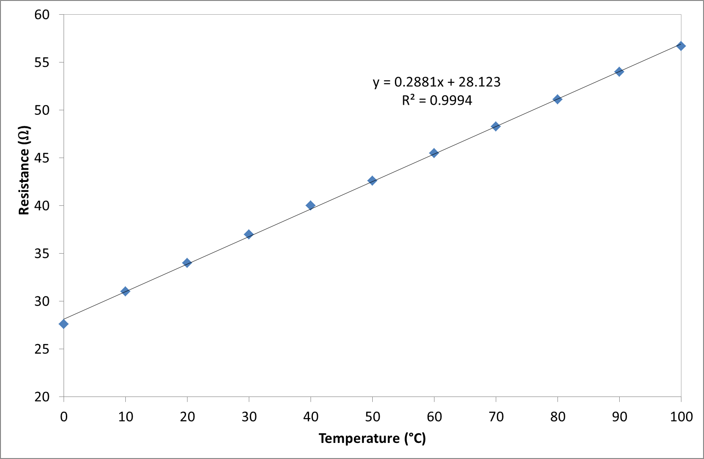
Figure 1: The graph shows the effect of temperature on the resistance of a typical resistor.

